1. LOGIN PAGE (PC & HP)
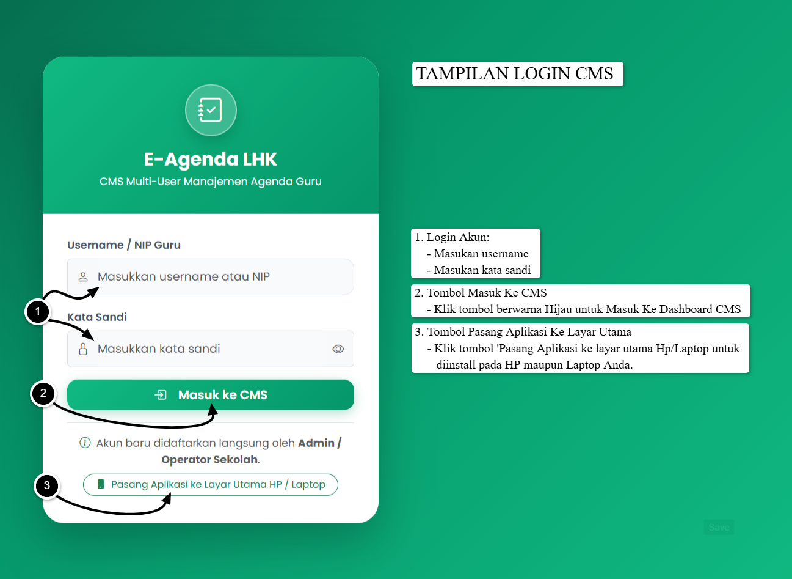
A. TAMPILAN PC/LAPTOP
2. DASHBOARD (PC) 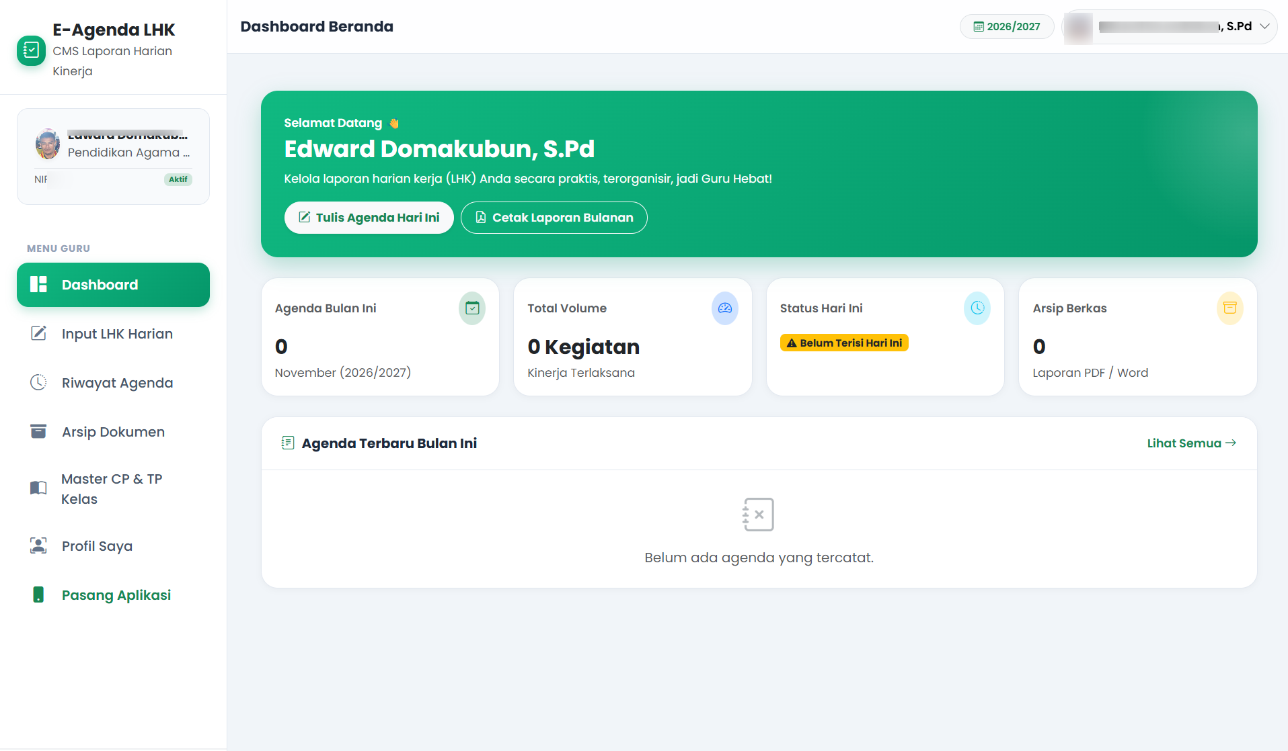

4. INPUT LHK HARIAN (PC)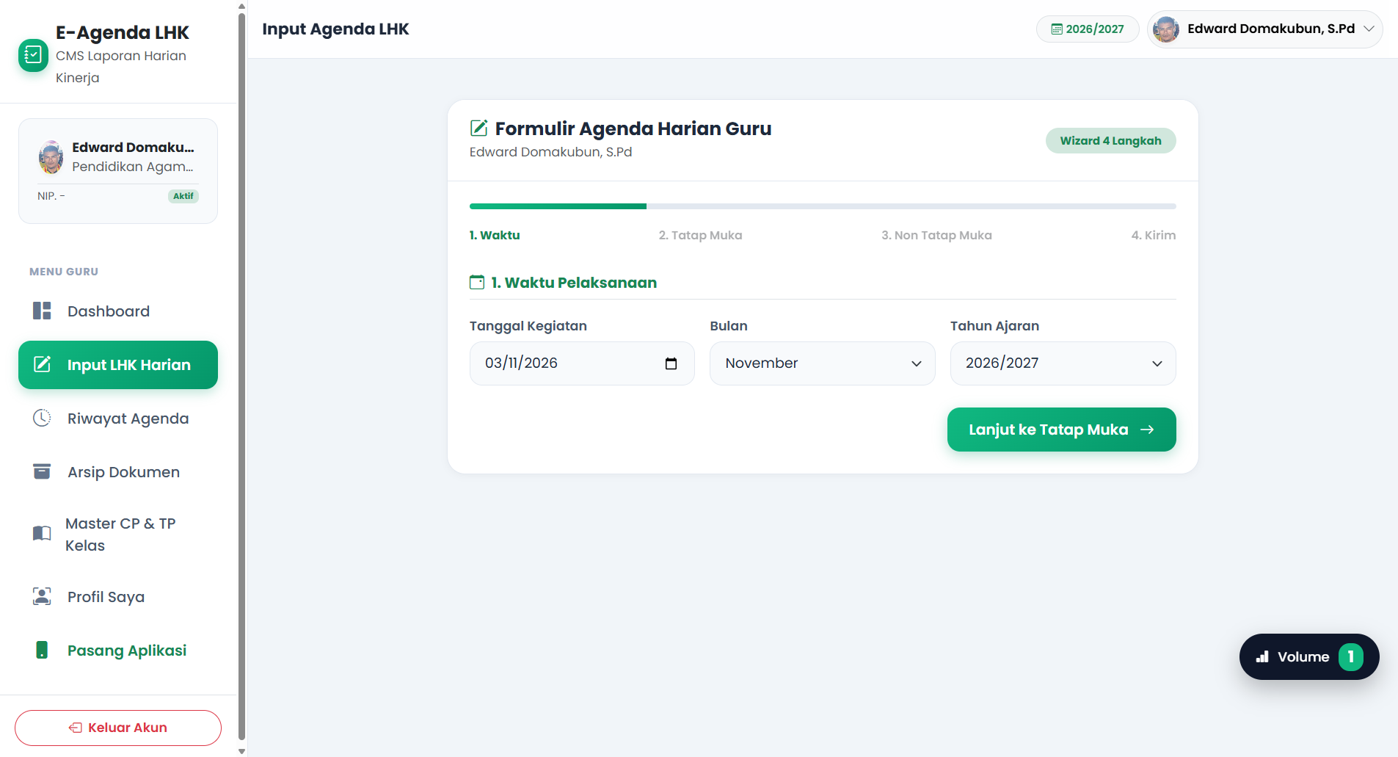
5. RIWAYAT AGENDA (PC)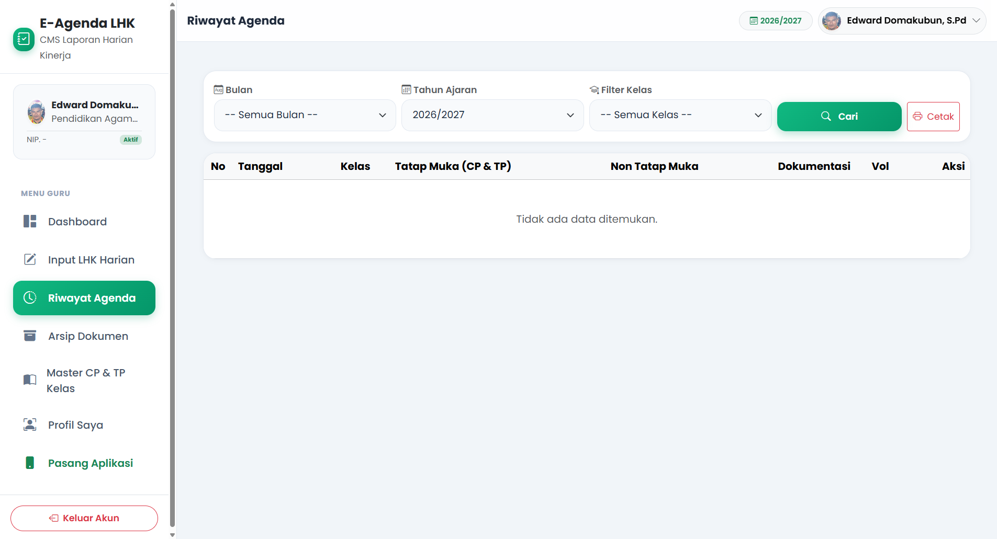
6. ARSIP DOKUMEN (PC)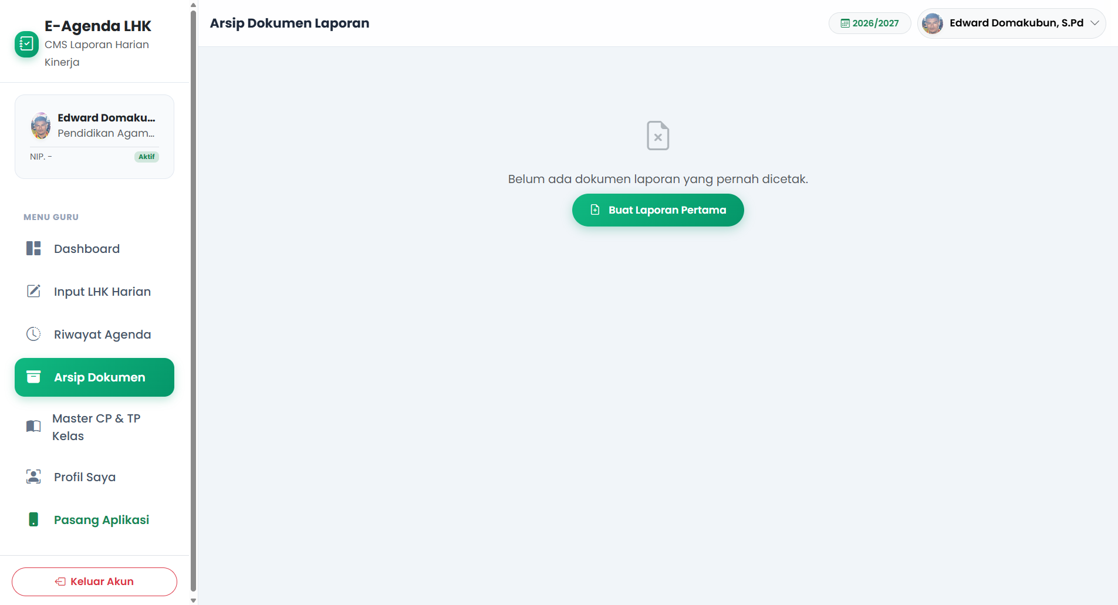
7. MASTER CP&TP KELAS (PC)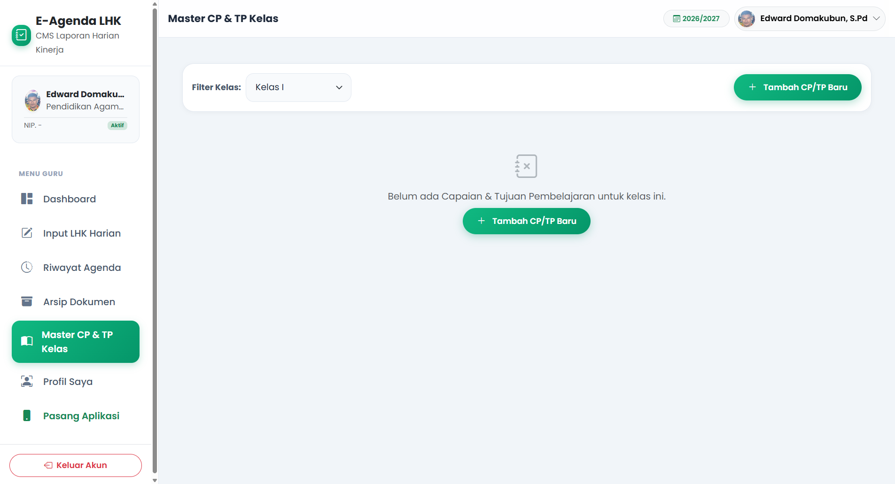
8. INPUT MASTER CP & TP KELAS (PC)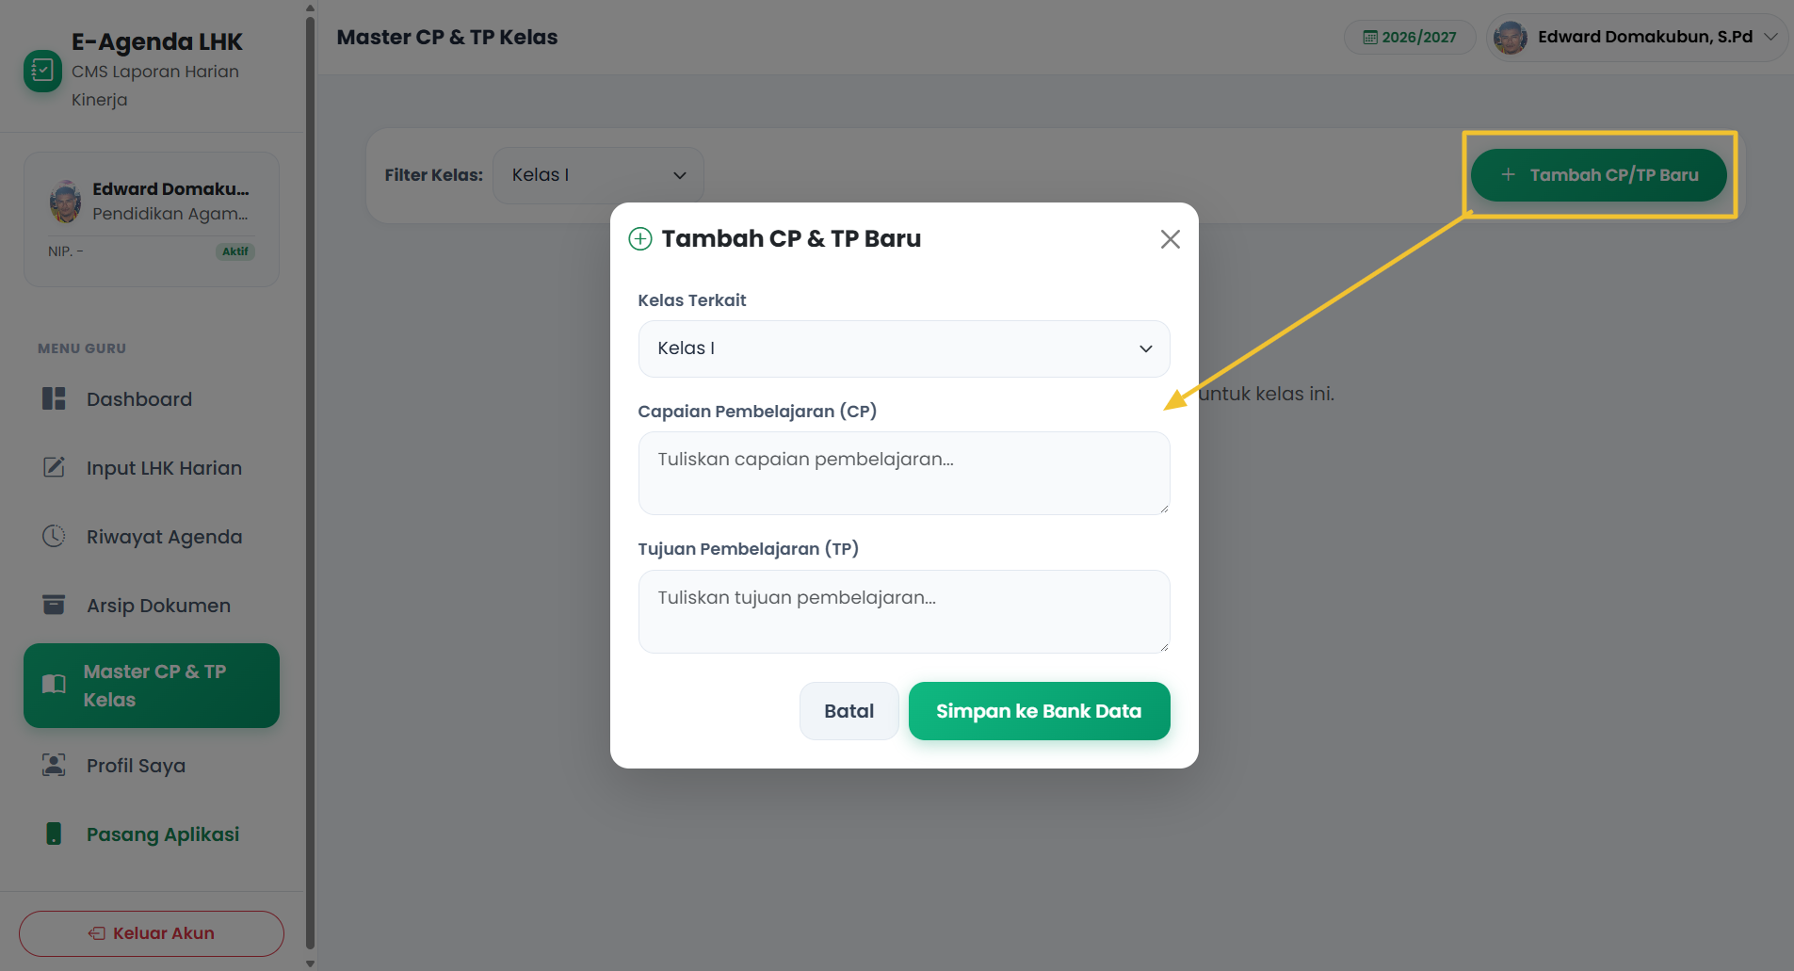
9. PROFILE GURU (PC)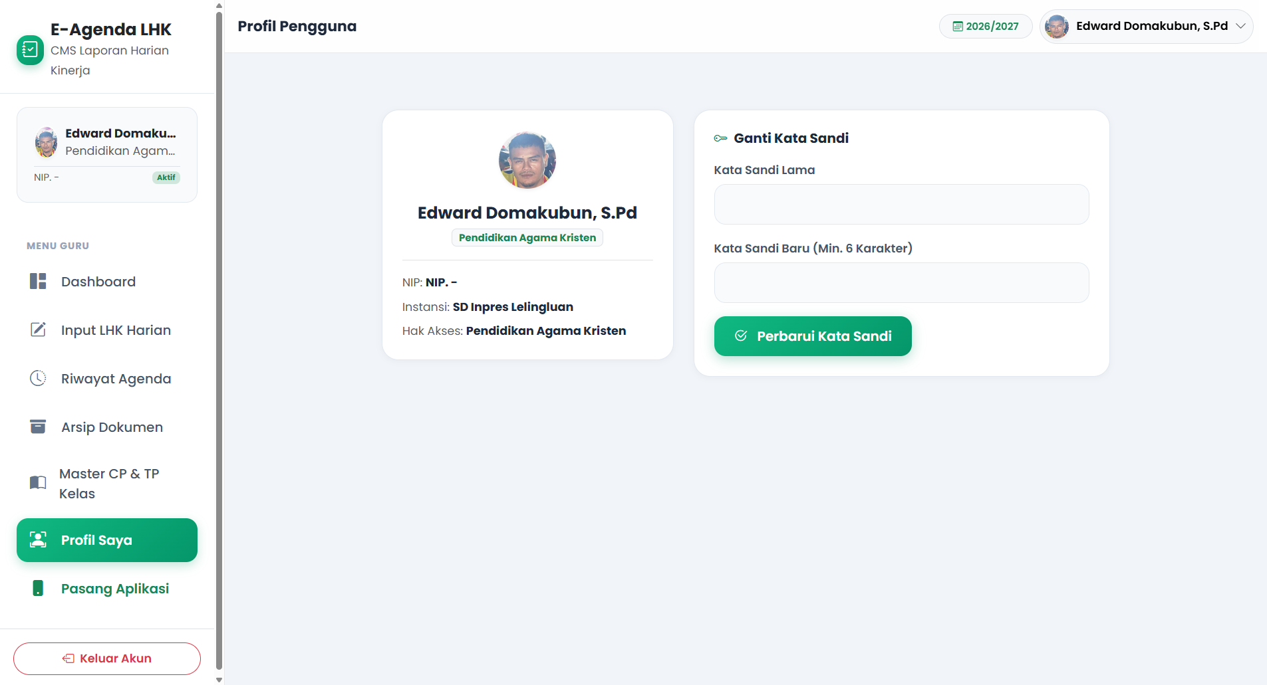

B. TAMPILAN MOBILE/HP
1. DASHBOARD (HP)
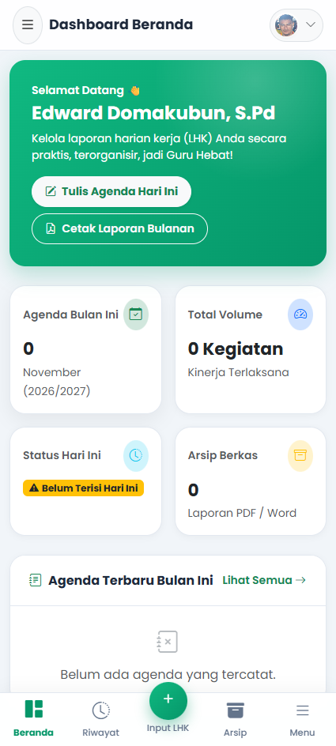

2. INPUT LHK HARIAN (HP)
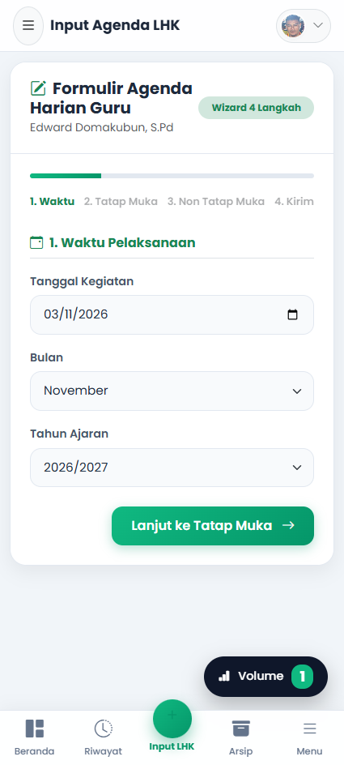
3. RIWAYAT AGENDA (HP)
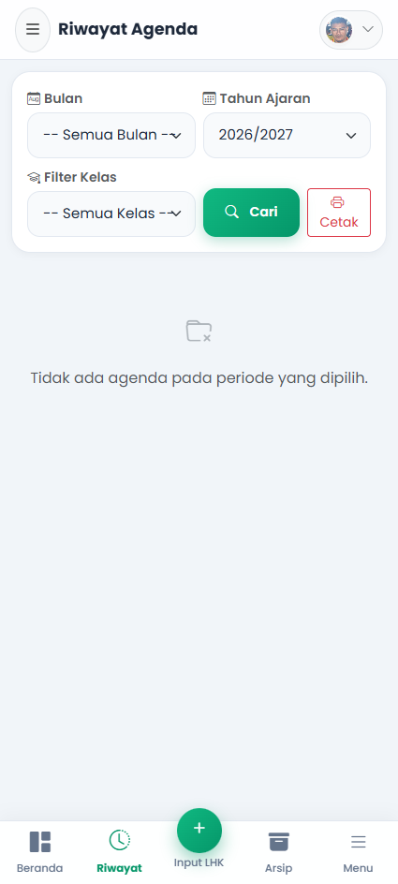

4. ARSIP DOKUMEN (HP)
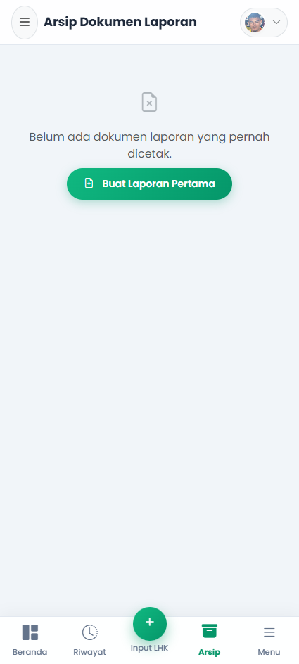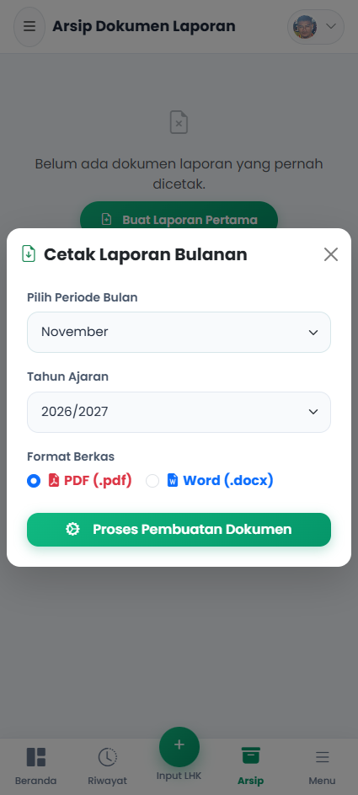
5. MENU SIDEBAR (HP)
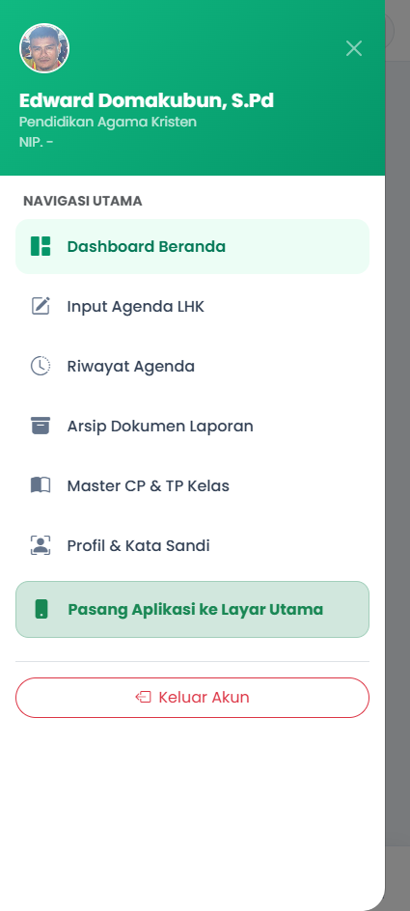

I. LOGO WEB CMS E-Agenda LHK CMS Laporan Harian Kinerja

II. Link website CMS
https://lhk-pak.cmsmanager.my.id
III. Panduan Detail Mulai Login Hingga Penggunaan Website CMS E-Agenda LHK CMS Laporan Harian Kinerja:

